Vishwakarma Institute of Technology
Department of Computer Engineering
A.Y. 2025-26 (Sem II)
Course: Design and Analysis of Algorithms
Tutorial 9: Dynamic Programming
- Let G(V,E) be weighted directed graph which doesn’t have any negative weight cycle (a directed cycle in which sum of weights of all the edges is less than zero). For vertices s,t in V and a non-negative integer k, let f(s,t,k) denotes weight of smallest weight path from s to t amongst all paths of length at most k. (By weight of path we mean sum of weights of all the edges in the path and by length of path we mean number of edges in the path). Give a concrete recurrence relation for f(s,t,k). Describe base case of the recurrence. Given graph G and vertices s, t. Use the recurrence to design an efficient dynamic programming algorithm for finding weight of best path from s to t. What is time complexity of your algorithm?

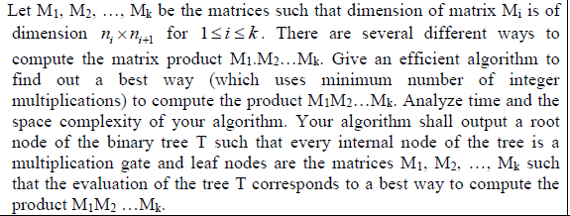

- Given a string s=s[1]s[2]…s[n] of length n, our goal is to find minimum number of characters to be inserted to make the string palindrome. For example, if s =” Ab3bd” the answer is 2, as we can get “dAb3bAd” by inserting 2 characters (one ‘d’, one ‘A’). For i>=j let f(i,j) is number of characters to be inserted in the string s[i]s[i+1]…s[j] to make it palindrome.
- Give a clean recurrence relation for f(i,j).
- Describe the base case of the recurrence.
- Using the recurrence and suitable memorization describe an algorithm which on input s, outputs the minimum number of characters to be inserted in s to make it palindrome? What is the time and the space complexity of your algorithm?

